Project Development Phase
Model Performance Test

Date | 10 February 2025
Team ID | LTVIP2026TMIDS91343
Project Name | Exploratory analysis of rain fall data in India for agriculture
Maximum Marks | 10 Marks

Model Performance Testing:
Project team shall fill the following information in model performance testing template.
S.N  o. | Param eter | Values | Screenshot
1 | Metric s | Regression Model:  MAE = 0.32  MSE = 0.21  RMSE = 0.46  R² Score = 0.81  Classification Model:  Confusion Matrix =  [[21220 857 61]  [3598 2639 75]  [358 74 310]  Accuracy Score = 0.83  Classification Report = Precision  = 0.81  Recall = 0.83  F1-Score = 0.81 | 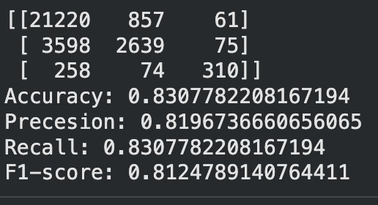
2 | Tune the  Model | Hyperparameter Tuning: Grid Search was used to optimize model parameters such as number of trees and maximum depth. Validation Method: KFold Cross Validation (k = 5)

